Smart Home Control System



**User Manual**

**Naveen Kularatne**

Table of Contents

General Information 3

System Overview 3

Organizational manual 3

System Summary 4

System configuration 4

User access level 4

The Smart Home System 5

User Interface 6

Light Control 6

The Door tab 7

Curtain Control 8

AC control 9

TV control 10

Fireplace Control 11

Master Switch 11

Login 12

# 1.0 General Information

General information section will explain the general terms of the system and the purpose of the system

## 1.1 System Overview

Smart home control system is an application that is created using labview. Which allows the user to control almost all the home appliances in the such as the TV, Lights, curtains and many more.

## 1.2 Organizational manual

The user manual consists of five sections: general infromation, System Summary, Introduction, User interface and the Login.

General information will explain the general terms of the systems and the purpose of the system.

The system summary section provides the general overview of the system. The summary outline of the systems hardware and software requirements and user access level.

Introduction sections provide the simple function of the system.

User interface will explain how to manipulate the user interface easily with screenshots.

Finally, the login will explain how the user can login to the system.

# 2.0 System Summary

System summary will provide a general overview of the system. The summary will outline the uses system configuration and user access level.

## 2.1 System configuration

The smart home control system is created using labVIEW 2011. The client side will control all the switches and the server will display the functions to the given switches on the client side.

## 2.2 User access level

Everyone can use this application, however only those who know the login username and password can access the switches in the house.

# 3.0 The Smart Home System

Welcome to the Smart control system ! You are about to experience new innovative ways to control almost every aspect of your home appliances. The Smart home control system eliminates every inconvenient constraint that you face when you control your home appliances. The user annual will provide detail description of all the Smart control system features.

Navigating the control panel

The main areas of the control panel are labeled below and are described in detailed on the following pages:

* Lights Control
* Door Control
* Curtain control
* AC control
* TV control
* Master Switch

Further, on every tab there will be a button, which will indicate that the appliance is switch on or switched off. Below is an example of the button

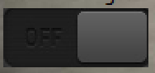

Figure. 1 Switched Off

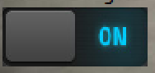

Figure. 1.1 Switched On

# 4.0 User Interface

## 4.1 Light Control

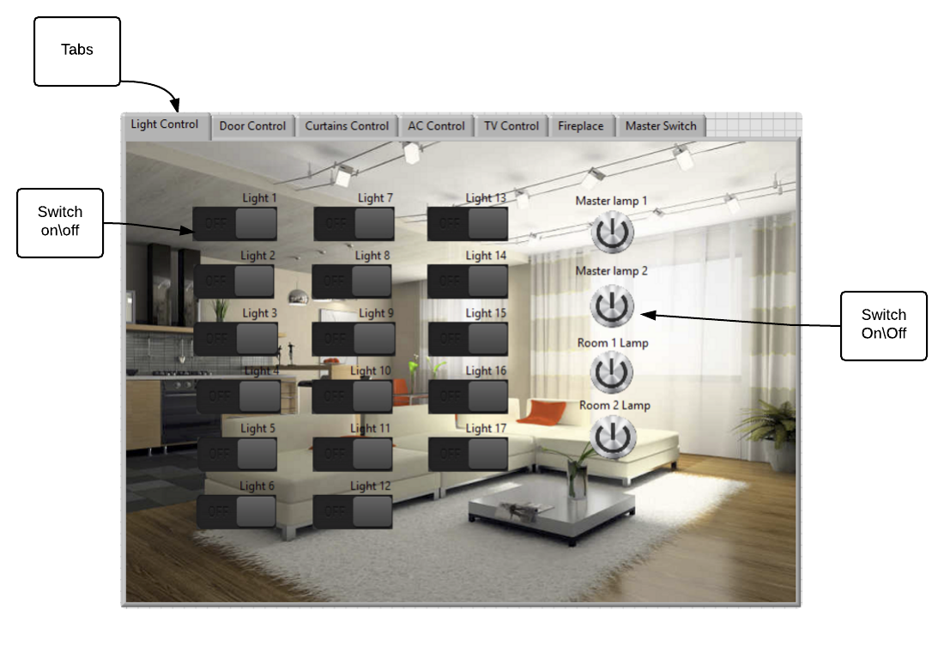

Figure. 2 Lights control

## 4.2 The Door tab

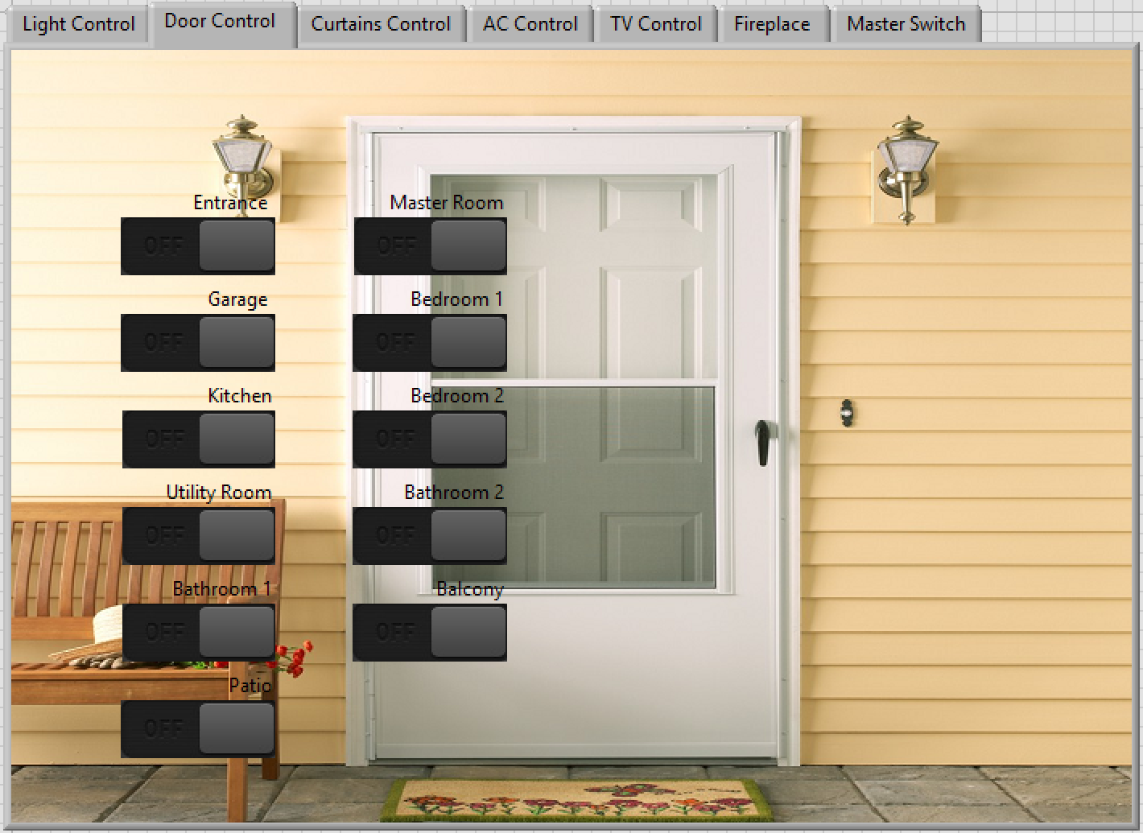

Figure. 3 Door tab

The door tab will control all the doors. When the button is switched on the LED button on the door light up, which will indicate that the door is unlocked.

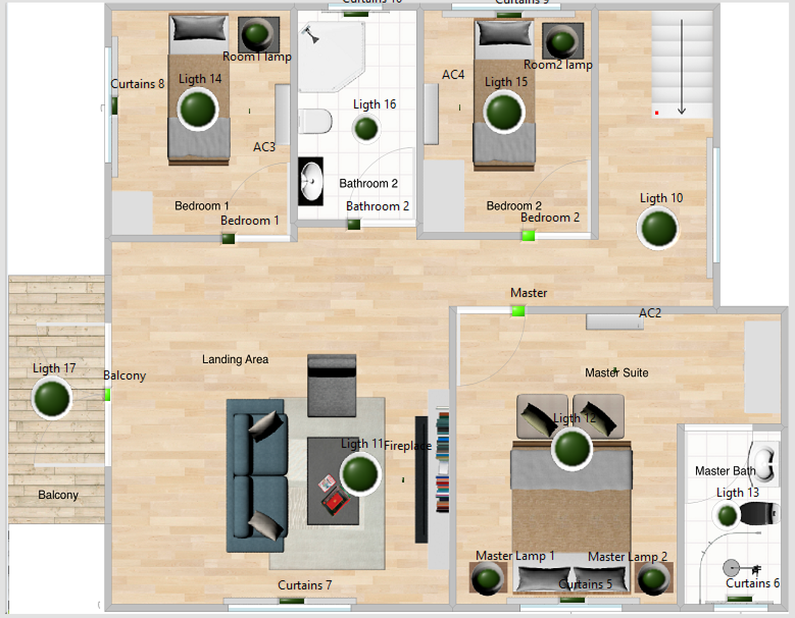

Figure 3.1 Door on

## 4.3 Curtain Control

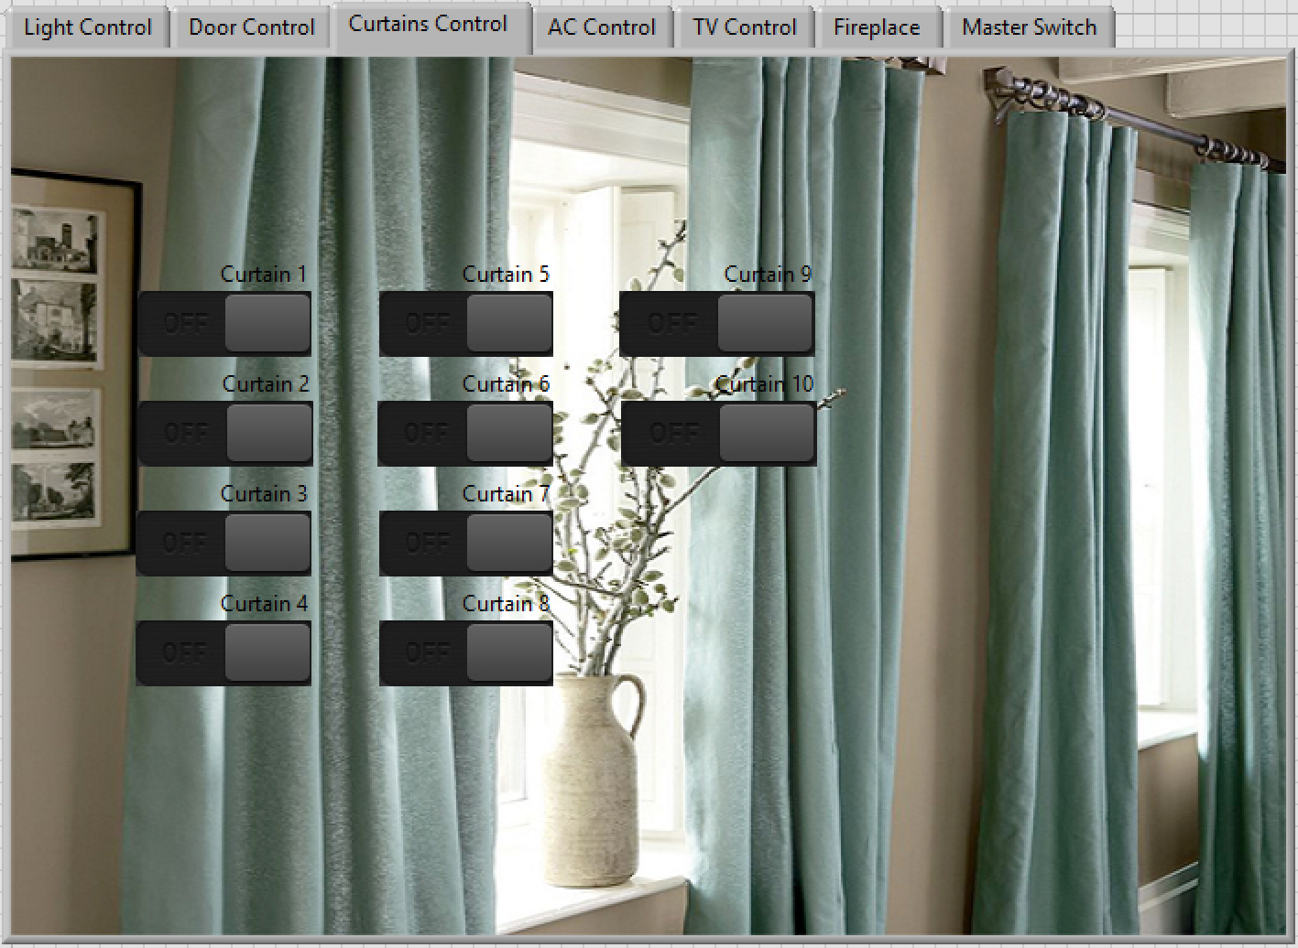

Figure. 4 Curtain Tab

The button will be connected to the electrical curtains. When the button is switched on, the LED light is turn up, which will indicate that the curtain is open. Below image is an example of this function.

## Macintosh HD:Users:Naveen:Desktop:screem:Curtain on server.PNG

Figure 4.1 Curtain on4.4 AC control

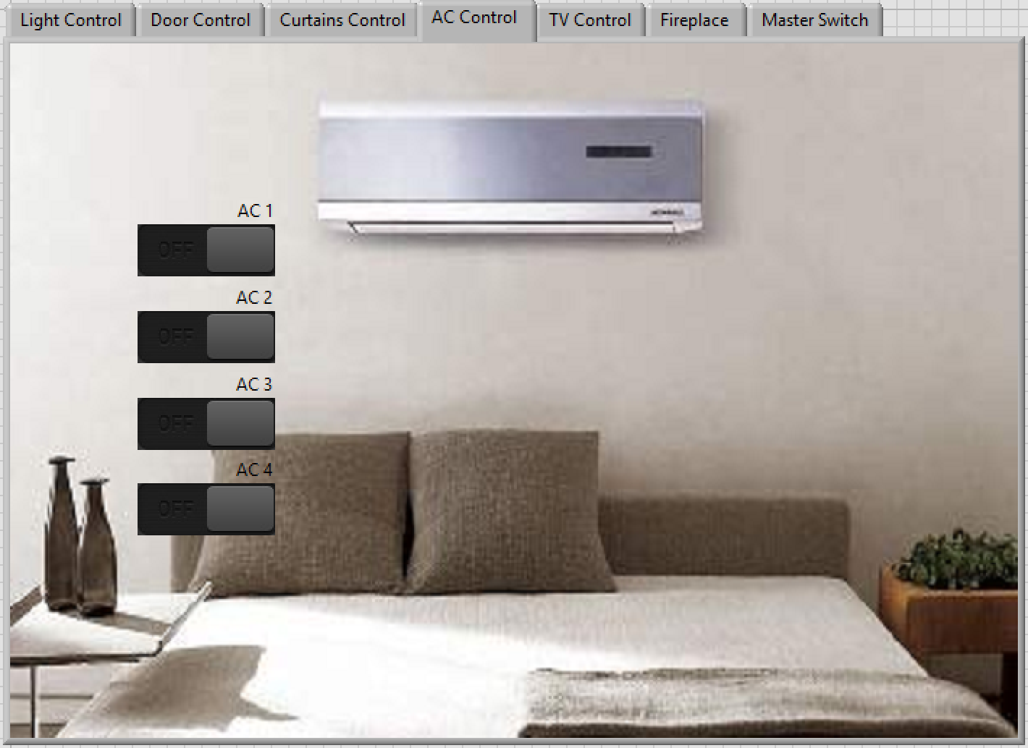

Figure. 5 AC Tab

When the button is switched on in the AC control tab, it will indicate that the AC is on by using GIF image. Below image is an example of this function

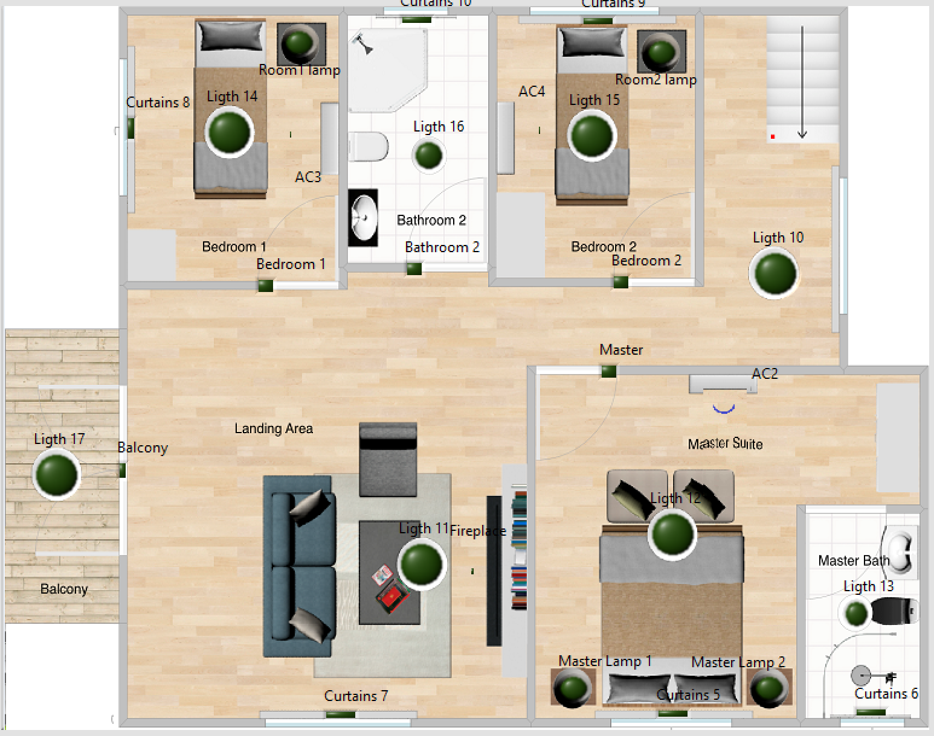

Figure. 5.1

## 4.5 TV control

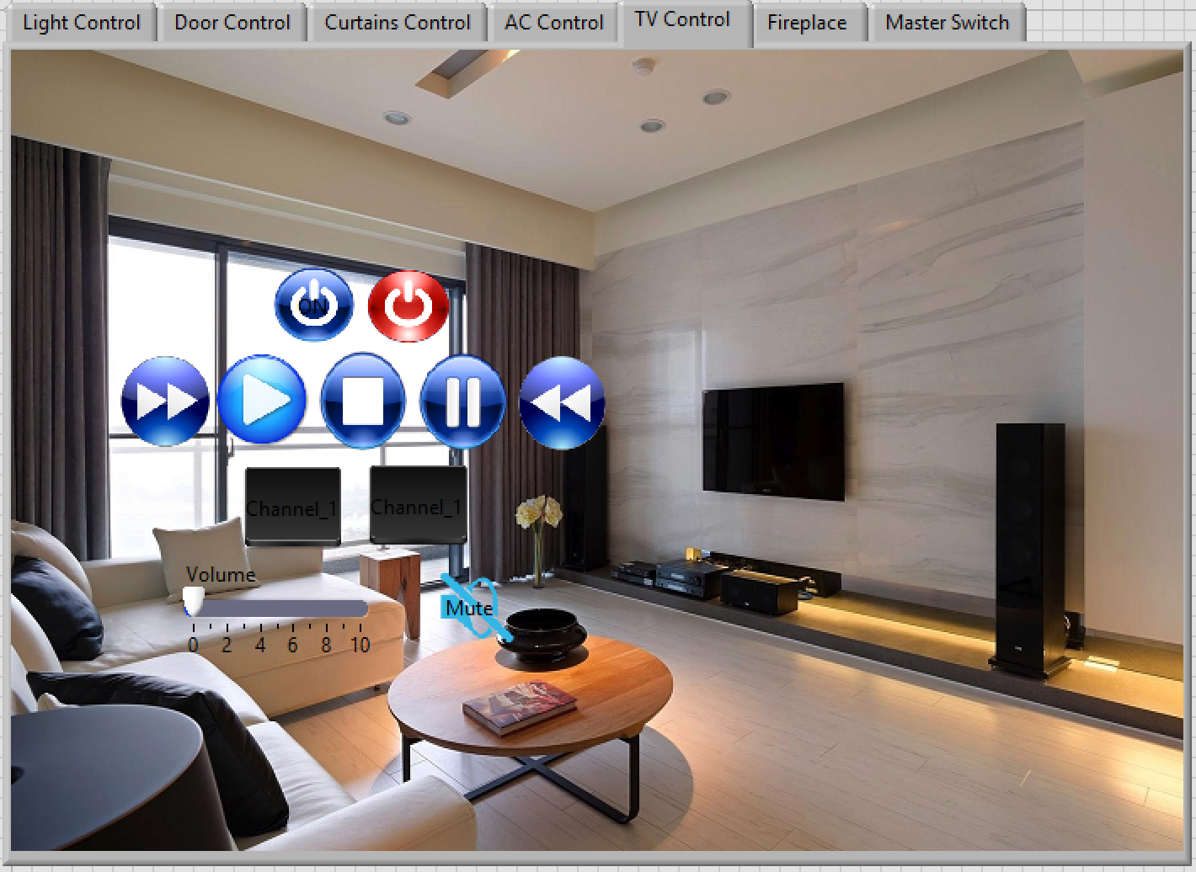

Figure. 6 TV Control

The TV control tab will control the channels and the basic function of a TV remote, which are on, off, fast forward, fast reverse, play, stop, pause, volume, and mute.

## 4.6 Fireplace Control

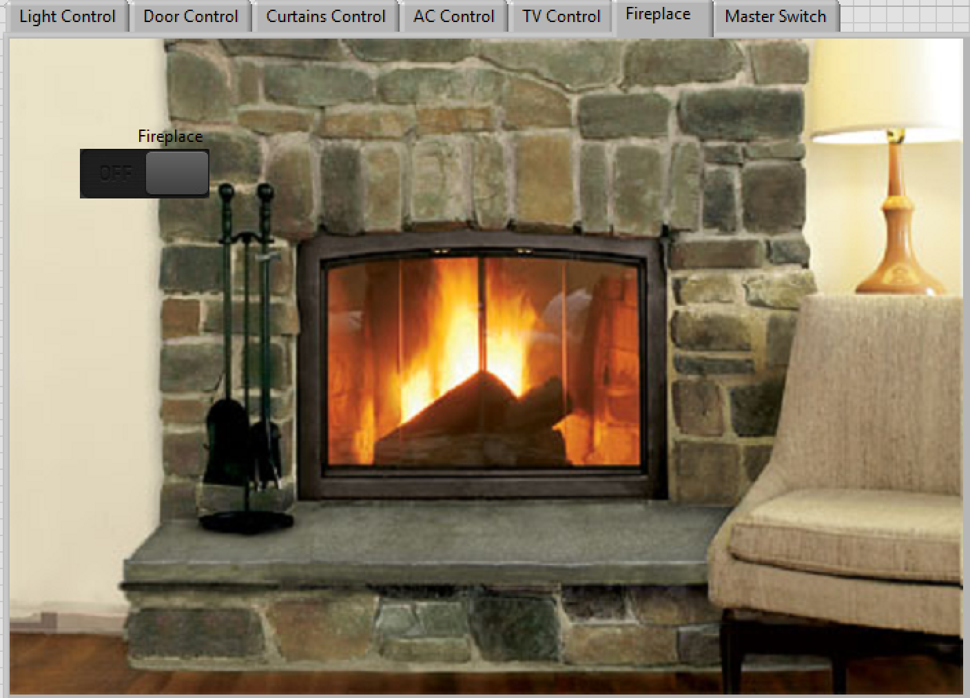

Figure. 7 Fireplace Tab

The Fireplace control is connected to the fireplace, when switched on it will indicate a GIF image when it’s on similar to the AC control.

## 4.7 Master Switch

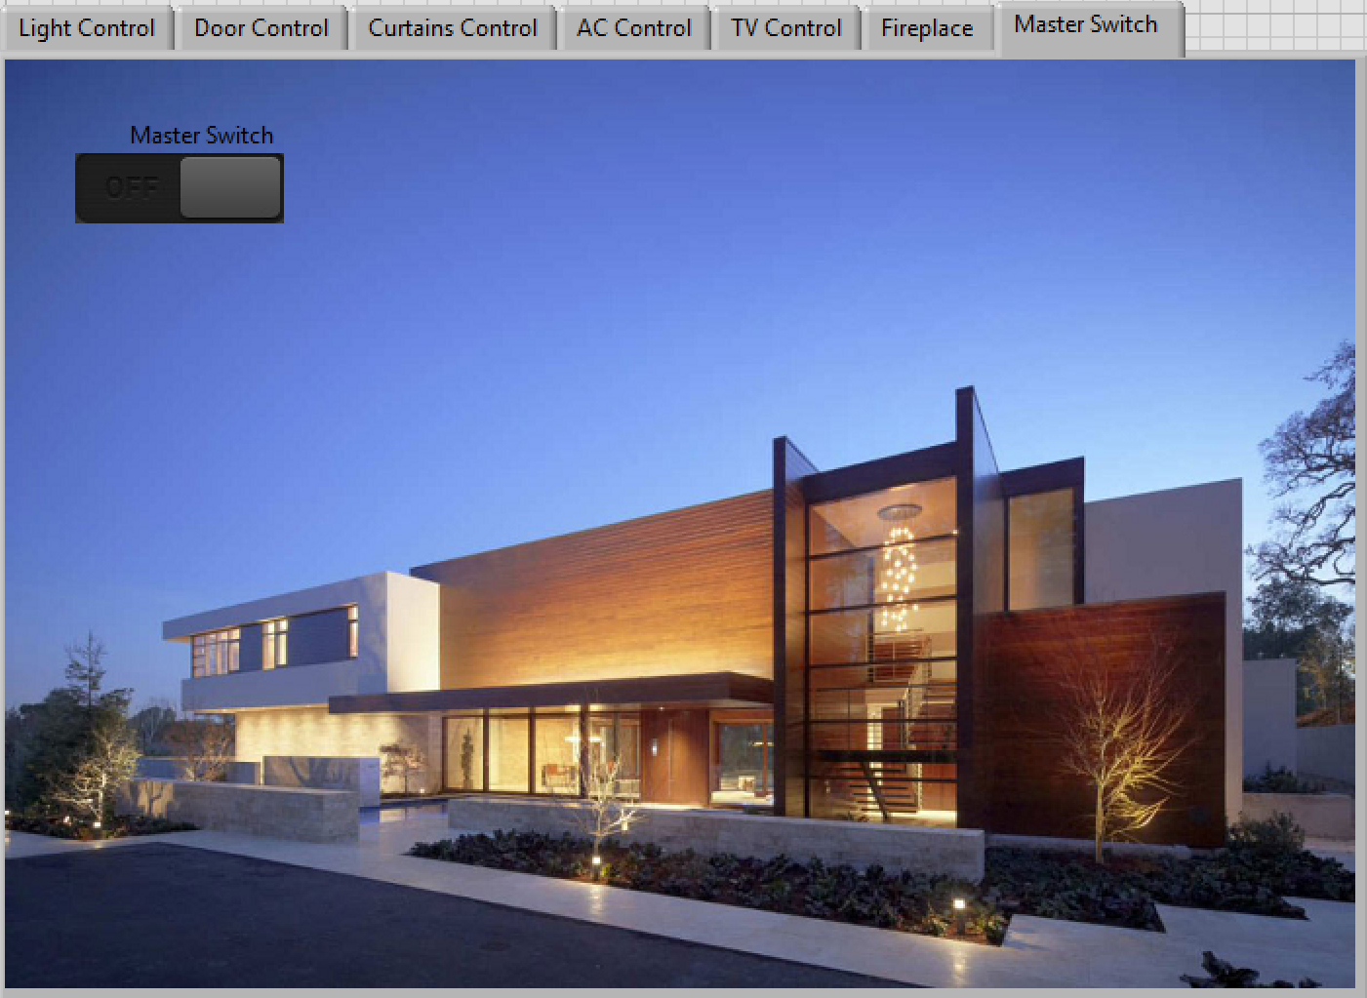

Figure. 8 Master Switch

Master switch is connected to all the buttons of all the tabs. When the master switch is turned on its turns off all the buttons of all the tabs.

# 5.0 Login

In order for the user to access the user interface, he/she must enter their correct username and password to access their home controls. Below is the login tab where the user must enter their correct username and password.

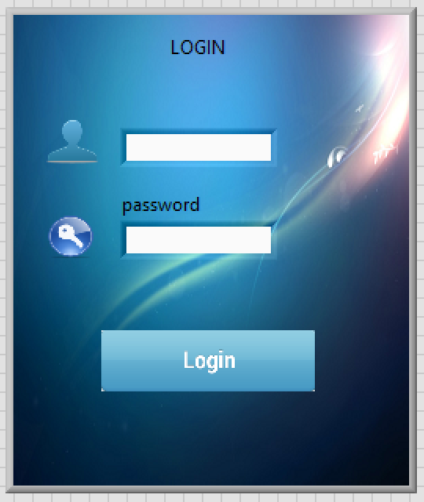

Figure. 9 Log In Tab

The default username and password is:

Username : admin

Password : admin